# **<https://www.youtube.com/watch?v=gYN2qN11-wE&ab_channel=PracticalNetworking>**

<https://www.javatpoint.com/linux-networking-commands>

<https://www.guru99.com/networking-interview-questions.html>

# **Difference Between Network and Internet**

#### **Key Difference between Network and Internet**

* Network is defined as a group of two or more connected computers that can share resources like a printer, an internet connection, an application, etc. Whereas the internet is a collection of interconnected devices which are spread across the globe.
* Network connects thousands of PC at one time, while the Internet connects millions of computers at one time.
* In a network, one entity has administrative rights to manage the network, whereas no entity controls the system on the Internet.
* Network objective is to exchange data and collaborates with peers, whereas the main Internet objective is to get knowledge and communicate over the Internet.
* The Network is a collection of computer systems and devices that are linked together using LAN, WAN, CAN, or HAN, whereas the Internet is a global system to link various types of electric devices worldwide.

## **What is a Network?**

The network is two or more connected computer which can share resource like a printer, an internet connection, application, etc. It is a collection of computer systems and devices which are linked together using a wireless network or via communication devices and transmission media.

The network provides connectivity between computers and devices within a restricted range where only one entity is controlled or authorized to manage the entire system..

## **What is the Internet?**

The Internet (Interconnected Network) is a global system which use TCP/IP protocol suite to link various types of electric devices worldwide. The internet is a collection of interconnected devices which are spread across the globe. It is a network of networks that consist of public, private, public, sales, finance, academic, business and government networks. ****The internet is a type of network and called network of networks.****

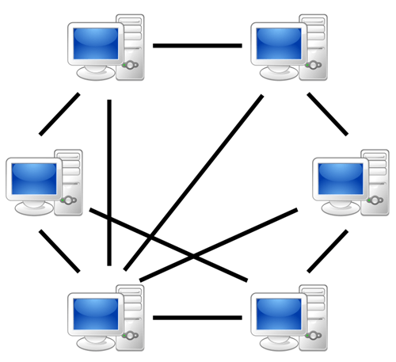

Computer Network

## **Network vs Internet – What is the difference between them?**

Here are important difference between Network and Internet:

| **Parameter** | **Network** | **Internet** |
| --- | --- | --- |
| Connection | Connect the system using different parameters. | Connect networks across the world. |
| Connectivity | One entity has administrative rights to manage the network | No entity controls the system. |
| Amount | Hundreds or a few thousand number of PC, get linked at one time. | Millions of computers get linked at one time. |
| Objective | To exchange data and collaborate with peers. | To get the knowledge and communicate over the Internet. |
| Type | Local Area Network, Wide Area Network, Campus Area Network, and Home Area Network. | World Wide Web. |

## **Types of Networks:**

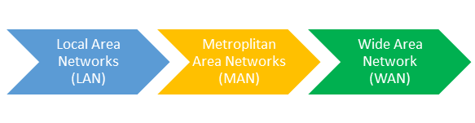

Three types of Networks are:

### **1) LAN (Local Area Network):**

LAN is a network that connects a small number of the system in a relatively close geographical area. E.g., a floor or nearby surrounding of a building.

### **2) MAN (Metropolitan area Network):**

It is a communication infrastructure that has been developed in and around large cities.

### **3) WAN (Wide Area Network:**

It is a network that connects two or more local-area networks over a large geographic distance. A WAN spans across a large geographic area, such as a state, province or country.

## **Why do you need a Network?**

The network offers the following advantages:

* Networks provide a fast and effective method for sharing & transferring files
* The network version of most software programs is available at considerable savings as compared to buying seat licensed copy for each of them.
* You don’t need to load all the software on every computer. Instead, load in the primary server and use on every computer connected to the network.
* Easy connectivity and fast communication
* Internet Access Sharing
* Helps you in performance enhancement and load balancing

## **Why do you need Internet?**

The network provides connectivity between computers and devices within a restricted range. In this system, only one entity is controlled or authorized to manage the entire system.

* The Internet is a network of computers at different locations around the world.
* Allows you to send an email message from every location
* Helps you to send or receive files between different computers
* Using the Internet, you can participate in discussion groups, such as mailing lists and newsgroups.
* It allows all small, medium and large size businesses to sell their products with less investments.
* It makes information available worldwide. So there’s no need to look for a good book in different libraries, as you can search for information over the Internet.
* It helps you updated with the latest news and technologies.
* It helps us meet people with the same interests as communities, forums, chats, websites, etc.
* It eases bills payment by facilitating bill payment online with the credit card and saves us time spent to stand up in the queue.

## **History of Network**

1950s -1960s:

Terminal-Oriented Computer Networks had begun which were very expensive. Therefore, time-sharing techniques were developed to allow them to be shared by many users.

1960s-1970s:

The cost of the computer dropped, and new applications emerged. It becomes essential to enable mainframe computers to interconnect and communicate with each other.

1960s – APRANET was the first real attempt of developing a network to interconnect computers over a wide geographic area

1980:

* The beginning of Local Area Networks (LANs)
* Affordable computers become available.
* Varieties of LAN topologies emerged like bus, ring, start, etc.

## **History of the Internet**

Here, are important milestones from the history of the Internet:

* In 1962, J.C.R. Licklide pioneered the concept of Intergalactic Computer Network
* In 1982 the Internet Protocol (TCP/IP) was standardized.
* In 1990, the World Wide Web introduced.
* In 1995, mainstream Search Engine Yahoo was created.
* In recent time, the Internet covers a large part of the globe and growing exponentially.

## **Features of Network**

Here, are important features of Network:

* Offers high capacity Load Balancing
* Indoor as well as Outdoor coverage options
* Determining by the weighted algorithm
* Web Content/Application Filtering

## **Features of Internet**

Here, are some important features of the Internet:

* A global network which connects millions of computers
* The internet is decentralized
* Every computer over the internet is independent
* There are various ways to access the internet

## **Disadvantages of Network**

* The network requires hardware, software which demands high initial setup costs.
* Some time it invites undesirable sharing.
* It may invite illegal or Undesirable behavior.
* Data security is quite a big concern in networking.
* Regular maintenance of a network needs considerable time and expertise.

## **Disadvantages of Internet**

* It allows everybody to speak about everything without any limitations or censorship. Could be a bad influence on impressionable minds.
* The search engines may display some unrelated results.
* Internet could replace face to face collaborations and make us lose the human touch.
* People working on internet-related fields need high speeds.
* Working constantly with or on the internet is surely tiring.
* The Internet makes us more a lazier – as for common thing like search the nearest restaurant or finding the best hotel.

Data Communication and Computer Networking provides the rules and regulations that allow computers with different operating systems, languages, cabling, and locations to share resources and communicate with each other.

## **What is a Computer Network?**

A computer network is a group of two or more interconnected computer systems. You can establish a network connection using either cable or wireless media.

Every network involves hardware and software that connects computers and tools.

## **Computer Network Components**

Here are essential computer network components:

### **Switches**

Switches work as a controller which connects computers, printers, and other hardware devices to a network in a campus or a building.

It allows devices on your network to communicate with each other, as well as with other networks. It helps you to share resources and reduce the costing of any organization.

### **Routers**

Routers help you to connect with multiple networks. It enables you to share a single internet connection with multiple devices and saves money. This networking component acts as a dispatcher, which allows you to analyze data sent across a network. It automatically selects the best route for data to travel and send it on its way.

### **Servers:**

Servers are computers that hold shared programs, files, and the network operating system. Servers allow access to network resources to all the users of the network.

### **Clients:**

Clients are computer devices which access and uses the network as well as shares network resources. They are also users of the network, as they can send and receive requests from the server.

### **Transmission Media:**

Transmission media is a carrier used to interconnect computers in a network, such as coaxial cable, twisted-pair wire, and optical fiber cable. It is also known as links, channels, or lines.

### **Access points**

Access points allow devices to connect to the wireless network without cables. A wireless network allows you to bring new devices and provides flexible support to mobile users.

****What is an Access Point?**** An [access point](https://www.ligowave.com/products/nft-series) is a wireless network device that acts as a portal for devices to connect to a local area network. Access points are used for extending the wireless coverage of an existing network and for increasing the number of users that can connect to it.  
A high-speed Ethernet cable runs from a router to an access point, which transforms the wired signal into a wireless one. Wireless connectivity is typically the only available option for access points, establishing links with end-devices using Wi-Fi.

### **Shared Data:**

Shared data are data which is shared between the clients such as data files, printer access programs, and email.

### **Network Interface Card:**

Network Interface card sends, receives data, and controls data flow between the computer and the network.

https://www.tutorialspoint.com/what-is-network-interface-card-nic

### **Local Operating System:**

A local OS which helps personal computers to access files, print to a local printer and uses one or more disk and CD drives which are located on the computer.

### **Network Operating System:**

The network operating system is a program which runs on computers and servers. It allows the computers to communicate via network.

### **Protocol:**

A protocol is the set of defined rules that allows two entities to communicate across the network. Some standard protocols used for this purpose are IP, TCP, UDP, FTP, etc.

### **Hub:**

Hub is a device that splits network connection into multiple computers. It acts a distribution center so whenever a computer requests any information from a computer or from the network it sends the request to the hub through a cable. The hub will receive the request and transmit it to the entire network.

### **LAN Cable:**

Local Area Network(LAN) cable is also called as Ethernet or data cable. It is used for connecting a device to the internet.

### **OSI:**

[OSI](https://www.guru99.com/layers-of-osi-model.html) stands for Open Systems Interconnection. It is a reference model which allows you to specify standards for communications.

## **Unique Identifiers of Network**

Below given are some unique network identifiers:

### **Hostname:**

Every device of the network is associated with a unique device, which is called hostname.

### **IP Address:**

IP (Internet Protocol) address is as a unique identifier for each device on the Internet. Length of the IP address is 32-bits. IPv6 address is 128 bits.

### **DNS Server:**

DNS stands for Domain Name System. It is a server which translates URL or web addresses into their corresponding IP addresses.

### **MAC Address:**

MAC (Media Access Control Address) is known as a physical address is a unique identifier of each host and is associated with the NIC (Network Interface Card). General length of MAC address is : 12-digit/ 6 bytes/ 48 bits

A MAC address (media access control address) is a 12-digit [hexadecimal](https://www.techtarget.com/whatis/definition/hexadecimal) number assigned to each device connected to the network. Primarily specified as a [unique identifier](https://www.techtarget.com/iotagenda/definition/unique-identifier-UID) during device manufacturing, the MAC address is often found on a device's network interface card ([NIC](https://www.techtarget.com/searchnetworking/definition/network-interface-card)). A MAC address is required when trying to locate a device or when performing diagnostics on a network device.

## **Why need Mac address?**

Here are pros/benefits of using [MAC address](https://www.guru99.com/what-is-mac-address.html):

* It provides a secure way to find senders or receivers in the network.
* MAC address helps you to prevent unwanted network access.
* MAC address is a unique number; hence it can be used to track the device.

### **Port:**

Port is a logical channel which allows network users to send or receive data to an application. Every host can have multiple applications running. Each of these applications are identified using the port number on which they are running.

## **Other Important Network Components**

### **ARP:**

[ARP](https://www.guru99.com/address-resolution-protocol.html) stands for Address Resolution Protocol which helps network users to convert the IP address into its corresponding Physical Address.

### **RARP:**

Reverse Address Resolution Protocol gives an IP address of the device with given a physical address as input.

## **Uses of Computer Networks**

Here are some common application of computer networks

* Helps you to share resource such as printers
* Allows you to share expensive software’s and database among network participants
* Provides fast and effective communication from one computer to another computer
* Helps you to exchange [data and information](https://www.guru99.com/difference-information-data.html) among users via a network.

## **Disadvantages of Computer Networking**

Here are drawbacks/ cons of using computer networks:

* Investment for hardware and software can be costly for initial set-up
* If you don’t take proper security precautions like file encryption, firewalls then your data will be at risk.
* Some components of the network design may not last for many years, and it will become useless or malfunction and need to be replaced.
* Requires time for constant administration
* Frequent server failure and issues of regular cable faults

# **Types of Network Topology: Bus, Ring, Star, Mesh, Tree Diagram**

## **What is Topology?**

Network topologies describe the methods in which all the elements of a network are mapped. The topology term refers to both the physical and logical layout of a network.

## **Types of Networking Topologies**

Two main types of network topologies in computer networks are 1) Physical topology 2) Logical topology

### **Physical topology:**

This type of network is an actual layout of the computer cables and other network devices

### **Logical topology:**

Logical topology gives insight’s about network’s physical design.

Different types of Physical Topologies are:

* P2P Topology
* Bus Topology
* Ring Topology
* Star Topology
* Tree Topology
* Mesh Topology
* Hybrid Topology

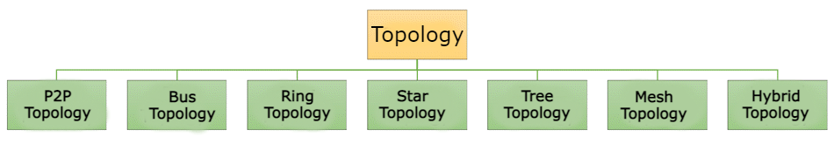Network Topology Diagram

Let’s learn each topology in detail:

## **Point to Point (P2P)**

Point-to-point topology is the easiest of all the network topologies. In this method, the network consists of a direct link between two computers.

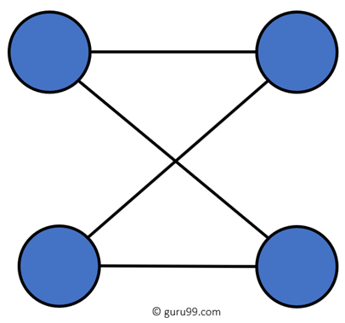

P2P Topology Diagram

### **Advantages:**

* This is faster and highly reliable than other types of connections since there is a direct connection.
* No need for a network operating system
* Does not need an expensive server as individual workstations are used to access the files
* No need for any dedicated network technicians because each user sets their permissions

### **Disadvantages:**

* The biggest drawback is that it only be used for small areas where computers are in close proximity.
* You can’t back up files and folders centrally
* There is no security besides the permissions. Users often do not require to log onto their workstations.

## **Bus Topology**

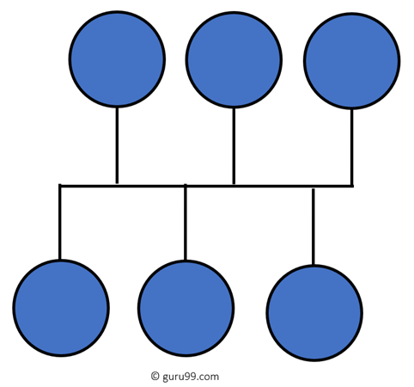

Bus Topology Diagram

Bus topology uses a single cable which connects all the included nodes. The main cable acts as a spine for the entire network. One of the computers in the network acts as the computer server. When it has two endpoints, it is known as a linear bus topology.

### **Advantages:**

Here are pros/benefits of using a bus topology:

* Cost of the cable is very less as compared to other topology, so it is widely used to build small networks.
* Famous for LAN network because they are inexpensive and easy to install.
* It is widely used when a network installation is small, simple, or temporary.
* It is one of the passive topologies. So computers on the bus only listen for data being sent, that are not responsible for moving the data from one computer to others.

### **Disadvantages:**

Here are the cons/drawbacks of bus topology:

* In case if the common cable fails, then the entire system will crash down.
* When network traffic is heavy, it develops collisions in the network.
* Whenever network traffic is heavy, or nodes are too many, the performance time of the network significantly decreases.
* Cables are always of a limited length.

## **Ring Topology**

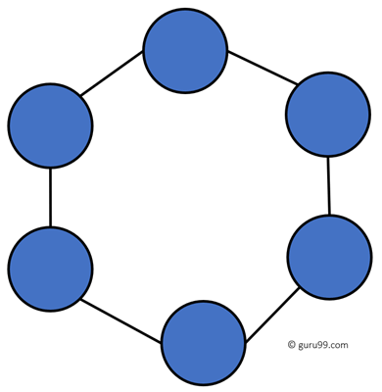

Ring Topology Diagram

In a ring network, every device has exactly two neighboring devices for communication purpose. It is called a ring topology as its formation is like a ring. In this topology, every computer is connected to another computer. Here, the last node is combined with a first one.

This topology uses token to pass the information from one computer to another. In this topology, all the messages travel through a ring in the same direction.

### **Advantages:**

Here are pros/benefits of ring topology:

* Easy to install and reconfigure.
* Adding or deleting a device in-ring topology needs you to move only two connections.
* The troubleshooting process is difficult in a ring topology.
* Failure of one computer can disturb the whole network.
* Offers equal access to all the computers of the networks
* Faster error checking and acknowledgment.

### **Disadvantages:**

Here are drawbacks/cons of ring topology:

* Unidirectional traffic.
* Break in a single ring can risk the breaking of the entire network
* Modern days high-speed LANs made this topology less popular.
* In the ring, topology signals are circulating at all times, which develops unwanted power consumption.
* It is very difficult to troubleshoot the ring network.
* Adding or removing the computers can disturb the network activity.

## **Star Topology**

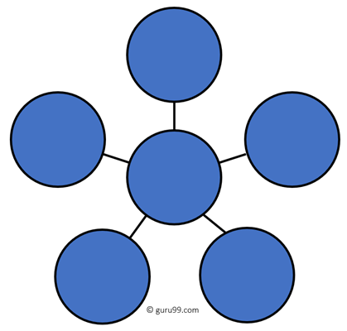

Star Topology Diagram

In the star topology, all the computers connect with the help of a hub. This cable is called a central node, and all other nodes are connected using this central node. It is most popular on LAN networks as they are inexpensive and easy to install.

### **Advantages:**

Here are pros/benefits of start topology:

* Easy to troubleshoot, set up, and modify.
* Only those nodes are affected, that has failed. Other nodes still work.
* Fast performance with few nodes and very low network traffic.
* In Star topology, addition, deletion, and moving of the devices are easy.

### **Disadvantages:**

Here are cons/drawbacks of using Star:

* If the hub or concentrator fails, attached nodes are disabled.
* Cost of installation of star topology is costly.
* Heavy network traffic can sometimes slow the bus considerably.
* Performance depends on the hub’s capacity
* A damaged cable or lack of proper termination may bring the network down.

## **Mesh Topology**

The mesh topology has a unique network design in which each computer on the network connects to every other. It is develops a P2P (point-to-point) connection between all the devices of the network. It offers a high level of redundancy, so even if one network cable fails, still data has an alternative path to reach its destination.

### **Types of Mesh Topology:**

* ****Partial Mesh Topology:****In this type of topology, most of the devices are connected almost similarly as full topology. The only difference is that few devices are connected with just two or three devices.

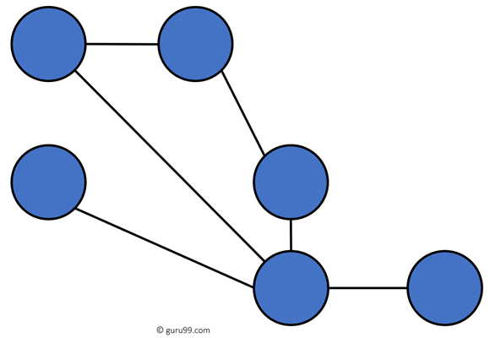

Partially Connected Mesh Topology

* ****Full Mesh Topology:****In this topology, every nodes or device are directly connected with each other.

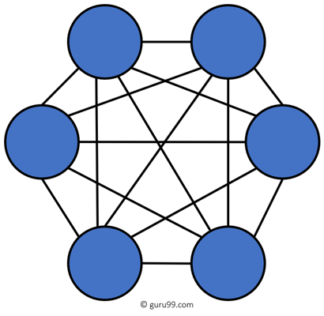

Fully Connected Mesh Topology

### **Advantages:**

Here, are pros/benefits of Mesh topology

* The network can be expanded without disrupting current users.
* Need extra capable compared with other LAN topologies.
* No traffic problem as nodes has dedicated links.
* Dedicated links help you to eliminate the traffic problem.
* A mesh topology is robust.
* It has multiple links, so if any single route is blocked, then other routes should be used for data communication.
* P2P links make the fault identification isolation process easy.
* It helps you to avoid the chances of network failure by connecting all the systems to a central node.
* Every system has its privacy and security.

### **Disadvantages:**

* Installation is complex because every node is connected to every node.
* It is expensive due to the use of more cables. No proper utilization of systems.
* Complicated implementation.
* It requires more space for dedicated links.
* Because of the amount of cabling and the number of input-outputs, it is expensive to implement.
* It requires a large space to run the cables.

## **Tree Topology**

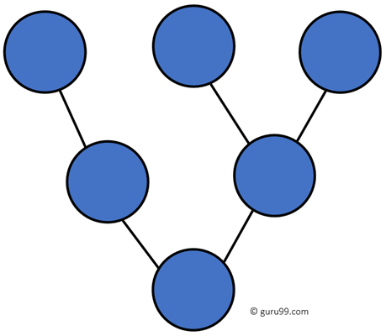

Tree Topology

Tree topologies have a root node, and all other nodes are connected which form a hierarchy. So it is also known as hierarchical topology. This topology integrates various star topologies together in a single bus, so it is known as a Star Bus topology. Tree topology is a very common network which is similar to a bus and star topology.

### **Advantages:**

Here are pros/benefits of tree topology:

* Failure of one node never affects the rest of the network.
* Node expansion is fast and easy.
* Detection of error is an easy process
* It is easy to manage and maintain

### **Disadvantages:**

Here are cons/drawback of tree topology:

* It is heavily cabled topology
* If more nodes are added, then its maintenance is difficult
* If the hub or concentrator fails, attached nodes are also disabled.

## **Hybrid Topology**

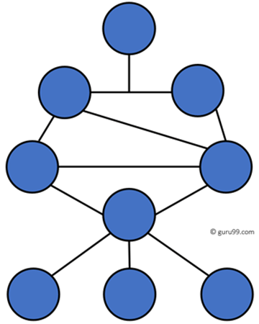Hybrid Topology

Hybrid topology combines two or more topologies. You can see in the above architecture in such a manner that the resulting network does not exhibit one of the standard topologies.

For example, as you can see in the above image that in an office in one department, Star and P2P topology is used. A hybrid topology is always produced when two different basic network topologies are connected.

### **Advantages:**

Here, are advantages/pros using Hybrid topology:

* Offers the easiest method for error detecting and troubleshooting
* Highly effective and flexible networking topology
* It is scalable so you can increase your network size

### **Disadvantages:**

* The design of hybrid topology is complex
* It is one of the costliest processes

## **How to select a Network Topology?**

Here are some important considerations for selecting the best topology to create a network in your organization:

* Bus topology is surely least expensive to install a network.
* If you want to use a shorter cable or you planning to expand the network is future, then star topology is the best choice for you.
* Fully mesh topology is theoretically an ideal choice as every device is connected to every other device.
* If you want to use twisted pair cable for networking, then you should build star topologies.

|  |  |  |
| --- | --- | --- |
| **Topology** | **What it is** | **Image** |
| P2P | The network consists of a direct link between two computers | IMG_265 |
| Bus | Uses a single cable which connects all the included nodes | IMG_266 |
| Ring | Every device has exactly two neighboring devices for communication purpose | IMG_267 |
| Star | All the computers connect with the help of a hub. | IMG_268 |
| Mesh | The mesh topology has a unique network design in which each computer on the network connects to every other. | IMG_269 IMG_270 |
| Tree | Tree topologies have a root node, and all other nodes are connected which forming a hierarchy. | IMG_271 |
| Hybrid Topology | Hybrid topology combines two or more topologies | IMG_272 |

## **Summary**

# **Types of Computer Network: What is LAN, MAN and WAN**

## **What is a Computer Network?**

A ****Computer Network**** is a group of two or more interconnected computer systems that use common connection protocols for sharing various resources and files. You can establish a computer network connection using either cable or wireless media. Every network involves hardware and software that connects computers and tools.

## **Different Types of Computer Networks**

There are various types of [Computer Networking](https://www.guru99.com/basic-computer-network.html) options available. The classification of network in computers can be done according to their size as well as their purpose.

The size of a network should be expressed by the geographic area and number of computers, which are a part of their networks. It includes devices housed in a single room to millions of devices spread across the world. Following are the popular types of Computer Network:

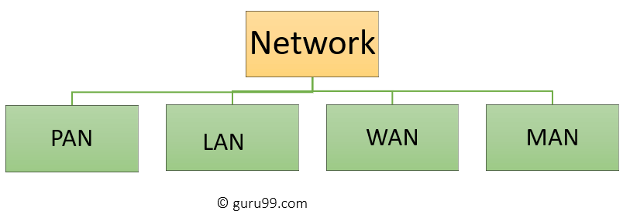

Types of Computer Networks

Some of the most popular computer network types are:

* PAN (Personal Area Network)
* LAN (Local Area Network)
* MAN (Metropolitan Area Network)
* WAN (Wide Area Network)

Let’s study all of these types of networking in detail.

## **What is PAN (Personal Area Network)?**

****PAN**** (Personal Area Network) is a computer network formed around a person. It generally consists of a computer, mobile, or personal digital assistant. PAN can be used for establishing communication among these personal devices for connecting to a digital network and the internet.

### **Characteristics of PAN**

Below are the main characteristics of PAN:

* It is mostly personal devices network equipped within a limited area.
* Allows you to handle the interconnection of IT devices at the surrounding of a single user.
* PAN includes mobile devices, tablet, and laptop.
* It can be wirelessly connected to the internet called WPAN.
* Appliances use for PAN: cordless mice, keyboards, and Bluetooth systems.

### **Advantages of PAN**

Here are the important pros/benefits of PAN network:

* PAN networks are relatively secure and safe
* It offers only short-range solution up to ten meters
* Strictly restricted to a small area

### **Disadvantages of PAN**

Here are the cons/drawbacks of using PAN network:

* It may establish a bad connection to other networks at the same radio bands.
* Distance limits.

## **What is a LAN (Local Area Network)?**

A ****Local Area Network**** (LAN) is a group of computer and peripheral devices which are connected in a limited area such as school, laboratory, home, and office building. It is a widely useful network for sharing resources like files, printers, games, and other application. The simplest type of LAN network is to connect computers and a printer in someone’s home or office. In general, LAN will be used as one type of transmission medium. It is a network which consists of less than 5000 interconnected devices across several buildings.

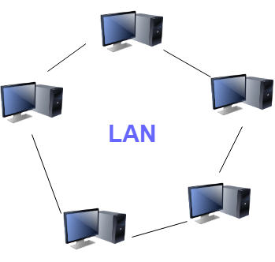

Local Area Network (LAN)

### **Characteristics of LAN**

Here are the important characteristics of a LAN network:

* It is a private network, so an outside regulatory body never controls it.
* LAN operates at a relatively higher speed compared to other WAN systems.
* There are various kinds of media access control methods like token ring and ethernet.

### **Advantages of LAN**

Here are the pros/benefits of LAN:

* Computer resources like hard-disks, DVD-ROM, and printers can share local area networks. This significantly reduces the cost of hardware purchases.
* You can use the same software over the network instead of purchasing the licensed software for each client in the network.
* Data of all network users can be stored on a single hard disk of the server computer.
* You can easily transfer data and messages over networked computers.
* It will be easy to manage data at only one place, which makes data more secure.
* Local Area Network offers the facility to share a single internet connection among all the LAN users.

### **Disadvantages of LAN**

Here are the cons/drawbacks of LAN:

* LAN will indeed save cost because of shared computer resources, but the initial cost of installing Local Area Networks is quite high.
* The LAN admin can check personal data files of every LAN user, so it does not offer good privacy.
* Unauthorized users can access critical data of an organization in case LAN admin is not able to secure centralized data repository.
* Local Area Network requires a constant LAN administration as there are issues related to software setup and hardware failures

## **What is WAN (Wide Area Network)?**

****WAN**** (Wide Area Network) is another important computer network that which is spread across a large geographical area. WAN network system could be a connection of a LAN which connects with other LAN’s using telephone lines and radio waves. It is mostly limited to an enterprise or an organization.

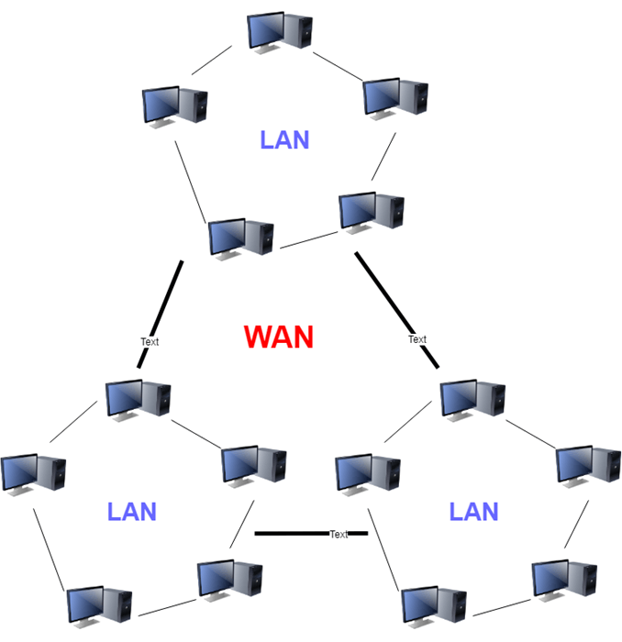

Wide Area Network (WAN)

### **Characteristics of WAN**

Below are the characteristics of WAN:

* The software files will be shared among all the users; therefore, all can access to the latest files.
* Any organization can form its global integrated network using WAN.

### **Advantages of WAN**

Here are the benefits/pros of WAN:

* WAN helps you to cover a larger geographical area. Therefore business offices situated at longer distances can easily communicate.
* Contains devices like mobile phones, laptop, tablet, computers, gaming consoles, etc.
* WLAN connections work using radio transmitters and receivers built into client devices.

### **Disadvantages of WAN**

Here are the drawbacks/cons of WAN network:

* The initial setup cost of investment is very high.
* It is difficult to maintain the WAN network. You need skilled technicians and network administrators.
* There are more errors and issues because of the wide coverage and the use of different technologies.
* It requires more time to resolve issues because of the involvement of multiple wired and wireless technologies.
* Offers lower security compared to other types of network in computer.

****Also Check:**** [LAN vs WAN: What’s the Difference?](https://www.guru99.com/lan-vs-wan.html)

## **What is MAN (Metropolitan Area Network)?**

A ****Metropolitan Area Network**** or MAN is consisting of a computer network across an entire city, college campus, or a small region. This type of network is large than a LAN, which is mostly limited to a single building or site. Depending upon the type of configuration, this type of network allows you to cover an area from several miles to tens of miles.

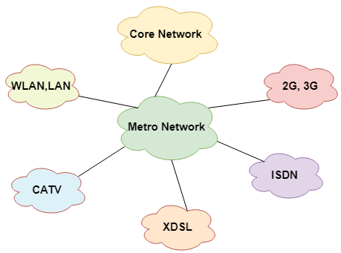

Metropolitan Area Network (MAN)

### **Characteristics of MAN**

Here are important characteristics of the MAN network:

* It mostly covers towns and cities in a maximum 50 km range
* Mostly used medium is optical fibers, cables
* Data rates adequate for distributed computing applications.

### **Advantages of MAN**

Here are the pros/benefits of MAN network:

* It offers fast communication using high-speed carriers, like [fiber optic cables](https://www.guru99.com/ethernet-cables-types.html).
* It provides excellent support for an extensive size network and greater access to WANs.
* The dual bus in MAN network provides support to transmit data in both directions concurrently.
* A MAN network mostly includes some areas of a city or an entire city.

### **Disadvantages of MAN**

Here are drawbacks/cons of using the MAN network:

* You need more cable to establish MAN connection from one place to another.
* In MAN network it is tough to make the system secure from hackers

## **Other Types of Computer Networks**

Apart from above mentioned computer networks, here are some other important types of networks:

* WLAN (Wireless Local Area Network)
* Storage Area Network
* System Area Network
* Home Area Network
* POLAN- Passive Optical LAN
* Enterprise private network
* Campus Area Network
* Virtual Area Network

Let’s see all these different types of networks in detail:

### **1) WLAN**

WLAN (Wireless Local Area Network) helps you to link single or multiple devices using wireless communication within a limited area like home, school, or office building. It gives users an ability to move around within a local coverage area which may be connected to the network. Today most modern day’s WLAN systems are based on IEEE 802.11 standards.

### **2) Storage-Area Network (SAN)**

A Storage Area Network is a type of network which allows consolidated, block-level data storage. It is mainly used to make storage devices, like disk arrays, optical jukeboxes, and tape libraries.

### **3) System-Area Network**

System Area Network is used for a local network. It offers high-speed connection in server-to-server and processor-to-processor applications. The computers connected on a SAN network operate as a single system at quite high speed.

### **4) Passive Optical Local Area Network**

POLAN is a networking technology which helps you to integrate into structured cabling. It allows you to resolve the issues of supporting Ethernet protocols and network apps.

POLAN allows you to use optical splitter which helps you to separate an optical signal from a single-mode optical fiber. It converts this single signal into multiple signals.

### **5) Home Area Network (HAN):**

A Home Area Network is always built using two or more interconnected computers to form a local area network (LAN) within the home. For example, in the United States, about 15 million homes have more than one computer.

These types of network connections help computer owners to interconnect with multiple computers. This network allows sharing files, programs, printers, and other peripherals.

### **6) Enterprise Private Network :**

Enterprise private network (EPN) networks are build and owned by businesses that want to securely connect numerous locations in order to share various computer resources.

### **7) Campus Area Network (CAN):**

A Campus Area Network is made up of an interconnection of LANs within a specific geographical area. For example, a university campus can be linked with a variety of campus buildings to connect all the academic departments.

### **8) Virtual Private Network:**

A VPN is a private network which uses a public network to connect remote sites or users together. The VPN network uses “virtual” connections routed through the internet from the enterprise’s private network or a third-party [VPN](https://www.guru99.com/best-free-vpns-for-windows.html) service to the remote site.

It is a free or paid service that keeps your web browsing secure and private over public WiFi hotspots.

## **Summary**

* Types of connections in computer networks can be categorized according to their size as well as their purpose
* PAN is a computer network which generally consists of a computer, mobile, or personal digital assistant
* LAN (Local Area Network) is a group of computer and peripheral devices which are connected in a limited area
* WAN (Wide Area Network) is another important computer network that which is spread across a large geographical area
* A metropolitan area network or MAN is consisting of a computer network across an entire city, college campus, or a small region
* WLAN is a wireless local area network that helps you to link single or multiple devices using. It uses wireless communication within a limited area like home, school, or office building.
* SAN is a storage area network is a type of network which allows consolidated, block-level data storage
* System area network offers high-speed connection in server-to-server applications, storage area networks, and processor-to-processor applications
* POLAN is a networking technology which helps you to integrate into structured cabling
* Home network (HAN) is a always built using two or more interconnected computers to form a local area network (LAN) within the home
* Enterprise private network (EPN) networks are build and owned by businesses that want to securely connect various locations
* Campus area network (CAN) is made up of an interconnection of LANs in a specific geographical area
* A VPN is a private network which uses a public network to connect remote sites or users together
* What does LAN stand for? – LAN stands for Local Area Network.
* What is the difference between LAN and WAN? – LAN is a computer network that covers a small geographic area, like a home, office, or group of buildings, while WAN is a computer network that covers a broader area.

Application layer:

* An application layer serves as a window for users and application processes to access network service.

## Functions of Application layer:

* ****File transfer, access, and management (FTAM):**** An application layer allows a user to access the files in a remote computer, to retrieve the files from a computer and to manage the files in a remote computer.
* ****Mail services:**** An application layer provides the facility for email forwarding and storage.
* Directory services: An application provides the distributed database sources and is used to provide that global information about various objects.

Presentation layer:

* It acts as a data translator for a network.
* This layer is a part of the operating system that converts the data from one presentation format to another format.
* The Presentation layer is also known as the syntax layer.

## Functions of Presentation layer:

* ****Translation:**** The processes in two systems exchange the information in the form of character strings, numbers and so on. Different computers use different encoding methods, the presentation layer handles the interoperability between the different encoding methods. It converts the data from sender-dependent format into a common format and changes the common format into receiver-dependent format at the receiving end.
* ****Encryption:**** Encryption is needed to maintain privacy. Encryption is a process of converting the sender-transmitted information into another form and sends the resulting message over the network.
* ****Compression:**** Data compression is a process of compressing the data, i.e., it reduces the number of bits to be transmitted. Data compression is very important in multimedia such as text, audio, video.

Session layer:

* The Session layer is used to establish, maintain and synchronizes the interaction between communicating devices.

## Functions of Session layer:

* ****Dialog control:**** Session layer acts as a dialog controller that creates a dialog between two processes or we can say that it allows the communication between two processes which can be either half-duplex or full-duplex.
* ****Synchronization:**** Session layer adds some checkpoints when transmitting the data in a sequence. If some error occurs in the middle of the transmission of data, then the transmission will take place again from the checkpoint. This process is known as Synchronization and recovery.

## Transport Layer:

* The main responsibility of the transport layer is to transfer the data completely.
* It receives the data from the upper layer and converts them into smaller units known as segments.
* This layer can be termed as an end-to-end layer as it provides a point-to-point connection between source and destination to deliver the data reliably.

****The two protocols used in this layer are:****

* ****Transmission Control Protocol****
  + It is a standard protocol that allows the systems to communicate over the internet.
  + It establishes and maintains a connection between hosts.
  + When data is sent over the TCP connection, then the TCP protocol divides the data into smaller units known as segments. Each segment travels over the internet using multiple routes, and they arrive in different orders at the destination. The transmission control protocol reorders the packets in the correct order at the receiving end.
* ****User Datagram Protocol****
  + User Datagram Protocol is a transport layer protocol.
  + It is an unreliable transport protocol as in this case receiver does not send any acknowledgment when the packet is received, the sender does not wait for any acknowledgment. Therefore, this makes a protocol unreliable.

Network Layer:

* It is a layer 3 that manages device addressing, tracks the location of devices on the network.
* Routers are the layer 3 devices, they are specified in this layer and used to provide the routing services within an internetwork.

## Functions of Network Layer:

* ****Internetworking:**** An internetworking is the main responsibility of the network layer. It provides a logical connection between different devices.
* **[Addressing](https://www.javatpoint.com/network-addressing)**:**** A Network layer adds the source and destination address to the header of the frame. Addressing is used to identify the device on the internet.
* **[Routing](https://www.javatpoint.com/computer-network-routing)**:**** Routing is the major component of the network layer, and it determines the best optimal path out of the multiple paths from source to the destination.
* ****Packetizing:**** A Network Layer receives the packets from the upper layer and converts them into packets. This process is known as Packetizing. It is achieved by internet protocol (IP).

Data-link layer:

* This layer is responsible for the error-free transfer of data frames.
* It is mainly responsible for the unique identification of each device that resides on a local network.
* It contains two sub-layers:
  + ****Logical Link Control Layer****
    - It is responsible for transferring the packets to the Network layer of the receiver that is receiving.
    - It identifies the address of the network layer protocol from the header.
    - It also provides flow control.
  + ****Media Access Control Layer****
    - A Media access control layer is a link between the Logical Link Control layer and the network's physical layer.
    - It is used for transferring the packets over the network.

## Functions of the Data-link layer

* ****Framing:**** The data link layer translates the physical's raw bit stream into packets known as Frames. The Data link layer adds the header and trailer to the frame. The header which is added to the frame contains the hardware destination and source address.
* ****Physical Addressing:**** The Data link layer adds a header to the frame that contains a destination address. The frame is transmitted to the destination address mentioned in the header.
* ****Flow Control:**** Flow control is the main functionality of the Data-link layer. It is the technique through which the constant data rate is maintained on both the sides so that no data get corrupted. It ensures that the transmitting station such as a server with higher processing speed does not exceed the receiving station, with lower processing speed.
* ****Error Control:**** Error control is achieved by adding a calculated value CRC (Cyclic Redundancy Check) that is placed to the Data link layer's trailer which is added to the message frame before it is sent to the physical layer. If any error seems to occurr, then the receiver sends the acknowledgment for the retransmission of the corrupted frames.
* ****Access Control:**** When two or more devices are connected to the same communication channel, then the data link layer protocols are used to determine which device has control over the link at a given time.

Physical layer:

* The main functionality of the physical layer is to transmit the individual bits from one node to another node.

## Functions of a Physical layer:

* ****Line Configuration:**** It defines the way how two or more devices can be connected physically.
* **[Data Transmission](https://www.javatpoint.com/computer-network-transmission-modes)**:**** It defines the transmission mode whether it is simplex, half-duplex or full-duplex mode between the two devices on the network.
* **[Topology](https://www.javatpoint.com/computer-network-topologies)**:**** It defines the way how network devices are arranged.
* ****Signals:**** It determines the type of the signal used for transmitting the information.

UTP - Unshielded twisted pair - 90-100m - cn be overcome by using Repeaters and Switches

NAT - Network address translation - allows multiple systems on a common network to share single connection to the internet.

VPN - Virtual private network

RIP - Routing information protocol. Used by router to transfer data from one network to the other.

ICMP - Internet Control Message protocol - used by devices of the same network to communicate problems with data transmission

IGMP - Internet Group Management Protocol -